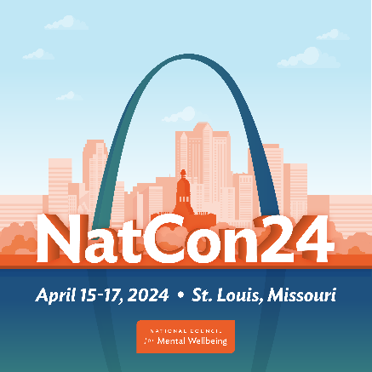

NatCon24 – Convince Your Boss Email Template
Are you interested in attending NatCon24? Need a little help convincing your boss? Use this email as a template or modify the copy to inform your own message.
Dear [Insert Name]:
I’m writing to request your approval to attend NatCon24, the National Council for Mental Wellbeing’s annual conference occurring in St. Louis from April 15-17.
As the biggest event in behavioral health care, NatCon24 is bringing together thousands of health care professionals for three days of nonstop learning and networking.
This is an opportunity for me to strengthen my skills, connect with the best minds in health care and build new relationships that can benefit our organization. I’ll get to:
- Share experiences with 5,000+ colleagues from across the country.
- Hear from hundreds of sought-after speakers and gain new perspectives.
- Explore the latest trends in mental health and substance use treatment.
- Earn continuing education or continuing medical education credits.
- Discover new technologies and tools that can benefit our work.
- Learn about the future of our field and our role in it.
Best of all, I’ll bring back new ideas, strategies and solutions we can use to increase our impact in the community and connect more people to high-quality, comprehensive care.
And the cost of registration will never be lower!
Right now, a full-conference pass costs $1,140 and a one-day pass costs $800 (members of the National Council get an additional discount). We have until Dec. 15 to lock in these rates!
I hope you agree this is a great opportunity for me to invest in myself and our organization. Thank you for your consideration, and please let me know if you have any questions!
Regards,
[Insert Name]

